High-Speed Real-Time Video Streaming Transmission

Team Members:
Maksym Holub (maks.golub.1991@gmail.com),
Oleh Kuzhylnyi (kuzhylny.oleg@gmail.com),
Oleksandr Ostrianko (sasha_ostrianko@mail.ru)

Scientific Advisor: Tymofii Khodniev
Email: t.khodniev@kpi.ua

Submitted for the 2019 Digilent Design Contest Europe

04.05.2019

Department of Design of Electronic Digital Equipment (DEDEC dept.),
Faculty of Electronics, National Technical University of Ukraine "Igor Sikorsky Kyiv Polytechnic Institute"
(NTUU "KPI")

Kyiv, Ukraine

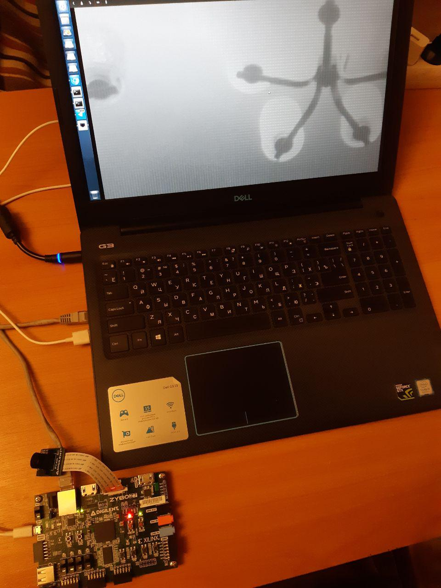

Photo of project
Table of Contents
Introduction 4
Background 7
Design 10
Tasks and Implementation 10
Design Overview 10
Hardware Design Description 11
The AXI Interconnect core connects one or more AXI memory-mapped master devices to 15
Hardware Design Summary 16
Software Design Description 16
Discussion 18
Limitations and Problems Encountered 18
Engineering Resources Used and Marketability 18
Community Feedback 18
References 19
Appendix A: arvfakegvcamera.c 20

Introduction

Overview

This report presents a prototype of the hardware-accelerated video streaming for real-time automation systems.
The real-time video streaming technologies find their use in a wide variety of practical applications. Video real-time streaming is used in television, medicine, surveillance, industrial process control and computer vision systems, in avionics and robotics. Considering the competitive streaming technologies, commonly implemented by networked IP cameras able to highlight: the RTSP, GigE Vision, USB3 Vision based.
For instance, USB3 cameras transmit flow to nearest host and do not able to communicate via network layers. In turn, RTSP-technology not so much strict in real-time video transmitting unlike GigE vision.
As follows the publication [1] the RTSP technology uses bandwidth less efficiency and it is an weakly detemined than GigE vision. In addition the RTSP is less predictable in traffic generation sence as shown below (Figure 1).
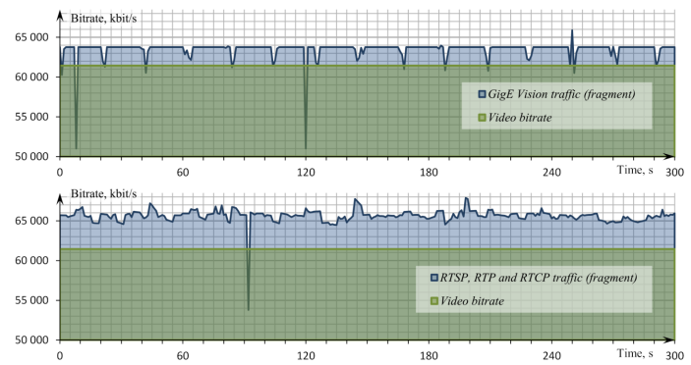
Figure 1 Fragments of captured traffic after discretization step for each streaming technology
GigE Vision cameras more oriented towards industrial applications (e.g. machine vision), has closed specification and ,moreover, ready-made cameras cost expensive. Every companies-manufactures add some minor corrections nevertheless do not interfere a compatible. In the result customers have to use some specific software for working with this cameras. Possible to make assumption that open use the GigE vision standard will be able to be very useful and powerful for custom implementations, if it will be necessary. For instance there need design a custom cameras which are using visible and infrared spectrum. For this necessary to use three-channel of the visible spectrum camera and in addition one-channel IR camera together. In the result becomes possible to transmit four channels from one camera. Imagine that anybody will able to design an own kind of custom GigE vision cameras.
Unfortunately, The GigE Vision standard is proprietary and requires licensing. In spite of this, there exists an open-source ARAVIS library [2], implementing the GigE Vision interface based on results of reverse engineering of the corresponding protocols. Accordingly, the ARAVIS library is coherence with GigE vision standard. It is a pretty similar situations with I2C standard which was implemented by Philips company and now is used by many chip-manufacturer vendors.
For making practical tests was designed the prototype of GigE vision camera. The prototype consists Digilent Pcam 5C camera which is connected to SoC FPGA. The 5C camera is used for the means of prototyping and could be replaced with a full-featured rolling or global shutter camera afterwards. The main complex part is connection FPGA SoC and ARM core (of course it is a benefit of using Zynq architecture) for running Linux software and get the ability to configure video-streaming module (e.g. pixel format, resolution). The resulting video-streaming is output to Ethernet layer. With the help of ready-made UI-viewer held video capturing and have the ability to check output video.
The hardware part of the project has been developed using Xilinx Vivado Design Suite and was built and synthesised via IP-cores.
The software part of the project has been developed via ARAVIS Library which was mentioned before and real-time videostream was configured via Video4Linux driver subsystem.

Summary of the design project

The design is complete and meets its objectives. The design has a modular approach and every component has a specific function (shown in Figure 2).
For project improving is possible to change the main camera to another powerful PHY-camera or vice versa use USB camera.

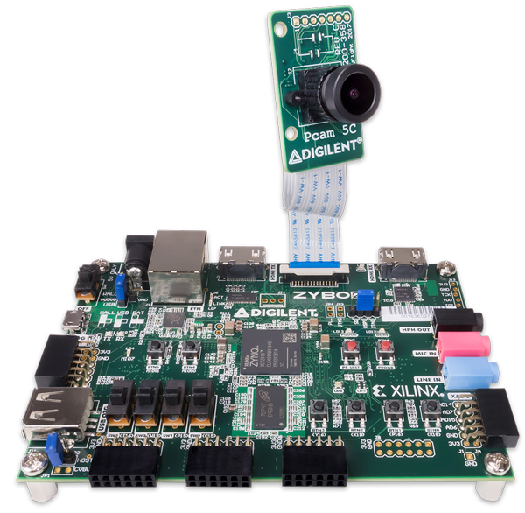
Figure 2 General view of prototype

Hardware requirements
- ZyboZ7-10 (Zynq-7000 ARM/FPGA SoC Development Board)
- Digilent Pcam 5C and ribbon cable for communication
- micro USB cable
- Power supply 5V/2A
- Cat-5e cable

Software requirements
- Runnig OS Linux Ubuntu v16.04
- Petalinux Tools
- Xilinx Vivado Design Suit 2018.2
- Open source ARAVIS v0.6.1 vision library for genicam based cameras
- Serial terminal CuteCom

Background

Preamble

This project is part of a large research area that is being developed at the Department of Design of Electronic Computing Equipment (DEDEC), Faculty of Electronics, Igor Sikorsky Kyiv Polytechnic Institute with the support of the Ministry of Education and Science of Ukraine. The final concept of the project formed based on research works published the results of which in scientific articles [1,3,4].

The possibility of using ARAVIS library for their own purposes

The Aravis library is focused on working with UNIX-like operating systems. Further work with it requires the use of an optimal platform, the choice of which will be justified in the next paragraph of this section.
The original distribution of the ARAVIS does not allow direct video streaming from the camera but includes a video viewer and ArvFake camera simulator. The ArvFake imitates the GigE Vision camera, but it can only emit a test video sequence in moving gradient pattern. To avoid that limitation, we can change the original source code of the ArvFake component to replace the gradient patterns with actual video flow gained from the camera.

Issues with the use of ready-made microprocessor

To implement our task, we need a camera module and microprocessing unit. Exemplary structure of a concept project is depicted on Figure 3. Camera module includes camera sensor and camera interface. Commonly used parallel (CPI) and serial (MIPI CSI) camera interfaces. Cameras with the parallel interface are conveniently connected to FPGA, but this interface adds a variety of issues that can result in reduced performance. MIPI CSI is a high-bandwidth low-energy interface and have support more than one camera. Serial interface (MIPI CSI) more popular and faster than parallel.

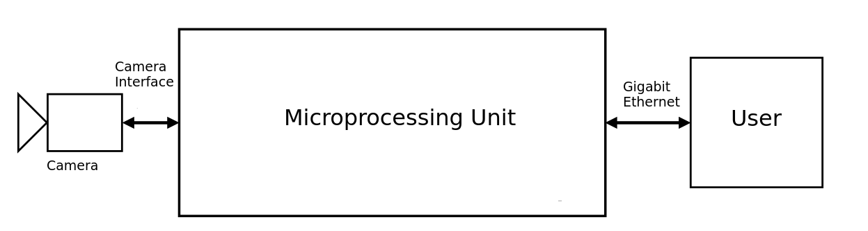

Figure 3 Structure of GigE Vision camera emulator

As a microprocessing unit, we can take ARM microprocessor with support MIPI camera interface, sufficient performance and open developer tool (open stage 1 bootloader and open source code signing tool). Also necessary that this microprocessor can always be purchased without any
restrictions. After careful consideration, we founded only two families of microprocessors: Texas Instruments Sitara (AM571x) and NXP i.MX6(SLL). Exemplar of both families have support MIPI CSI-2 on board. However, researches have shown that both exemplars have got a serious drawback — hardware buffering of video frames, which add delay. This delay becomes critical when the camera is used as a part of complex real-time automation systems. We concluded that other supplies in the world market of microprocessors have hardware buffering of the video frame.
Our solution to this problem is relying on a custom flexible realization of MIPI receiver module. Instead of acquiring and buffering the whole video frame before the transmission, it uses buffering only for parts of the frame, allows into reducing the delay. To achieve this goal we were able to use ARM+FPGA System-on-Crystal like Xilinx Zynq-7000 and MIPI IP-Core. The Xilinx provides an intellectual property (IP) centric design flow that lets us add IP modules to design from various design sources. Central to the environment is an extensible IP catalog that contains Xilinx-delivered Plug-and-Play IP.
Our implementation based on general board with a camera module connected to it. For instance, cameras have image sensors with a rolling and global shutter. Sensors with a rolling shutter do not expose all the pixels at the same time. Alternatively, they expose the pixels by row with each row having a different start and end time frame. Each of the rows start and end point have a delay as the sensor is fully read out. The result of this on moving objects is a skewed image. Image sensors with a global shutter allow all of the pixels to accumulate a charge with the exposure starting and ending at the same time. At the end of the exposure time, the charge is read out simultaneously. In turn, the image has no motion blur on moving objects. In our case, both shutters are suitable for use. However, for global shutter, the time of exposure must be a very small.

Design

Tasks and Implementation

In the context of Digilent Contest we created and tested the GigE Vision camera bridge prototype. For prototyping, we use the remarkable Digilent Zybo Z7-10 board and Digilent Pcam 5C camera with rolling shutter sensor.
The tasks that were set before us:
- Create and customize FPGA design with MIPI CSI-2 interface to our development board.
- Build a custom distribution of Linux based on ARM-part of Xilinx Soc;
- Test the connection between Linux distribution and camera;
- Include in distribution ARAVIS library and other necessary dependencies;
- Build and test a software module on the development board for transmitting a video stream;
- Launch the created software module on the Zybo Z7-10 board. Transmit the output video with FullHD resolution stream from the camera to the PC via Ethernet link;
For implementing these tasks, we created hardware and software design. In our case, hardware design it is implementation MIPI Camera bridge transmitting data, software implementation it is creating custom Linux distribution and work with ARAVIS. A description of both parts of the design will be introduced in the following paragraphs.

Design Overview

On our board comprises ARM+FPGA System-on-Crystal. On FPGA part we implemented a MIPI CSI interface and other peripherals with help Xilinx IP-cores. Also, we used Embedded Linux running on top of the ARM core part of the Xilinx SoC. We have made a custom Linux distribution based on the Xilinx PetaLinux Project. Our distribution must have a connection with the camera across the FPGA-part. ARAVIS library added to our distribution with a help of the corresponding layer. Special software module which based on ARAVIS library received frames from camera and transmit these frames across Ethernet interface to users. Block diagram of a project is depicted on Figure 4.

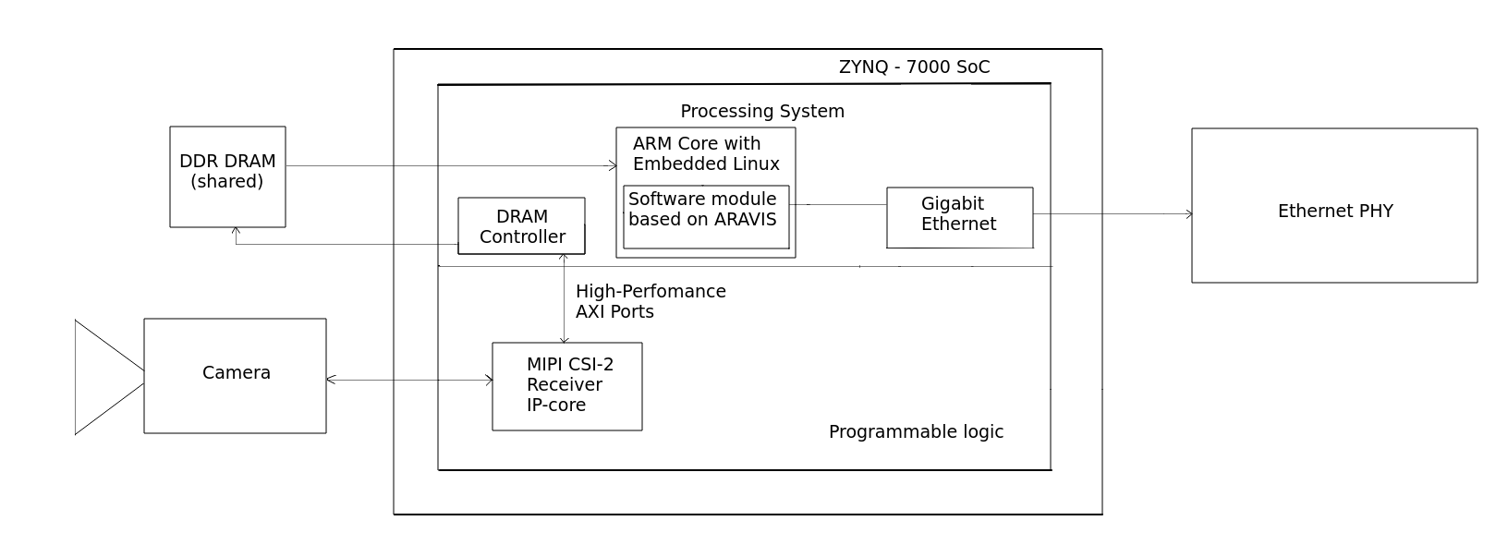
Figure 4 Block diagram of a project

Hardware Design Description

As a starting point, we used Zybo Z7-20 base-Linux project from Digilent [5], which already has a MIPI CSI-2 Receiver subsystem. All items of a block diagram of a project are depicted on Figure 5. Project was ported to Zybo Z7-10 board. Also the components non-present on Zybo Z7-10 board were eliminated. We save some other peripherals for any tests that are not included in this project.
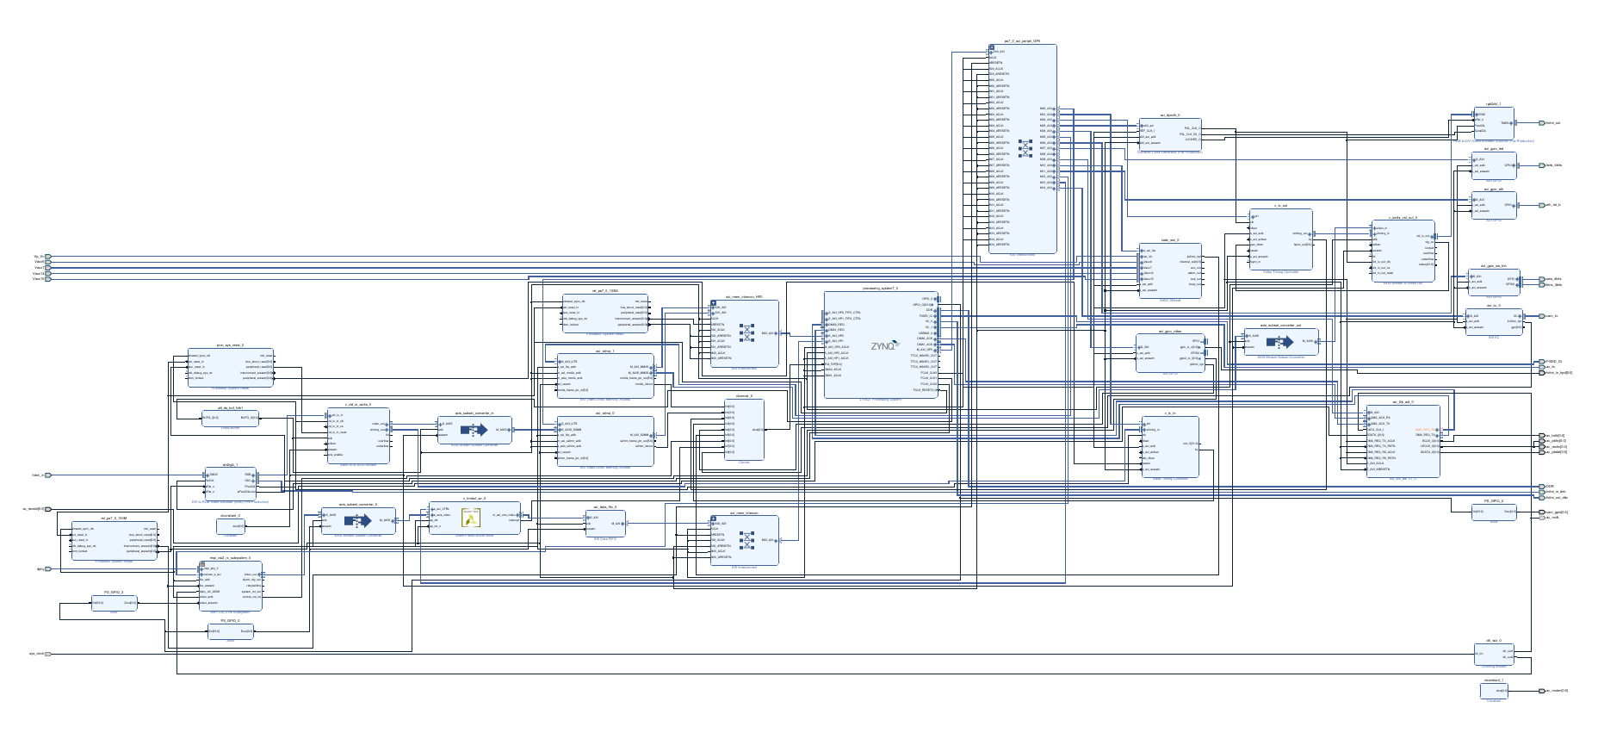
Figure 5 Top level block diagram

Let's describe in more detail the part of diagram with MIPI CSI-2 Receiver Subsystem IP-core (MIPI CSI-2 Rx). This part is depicted on Figure 6.
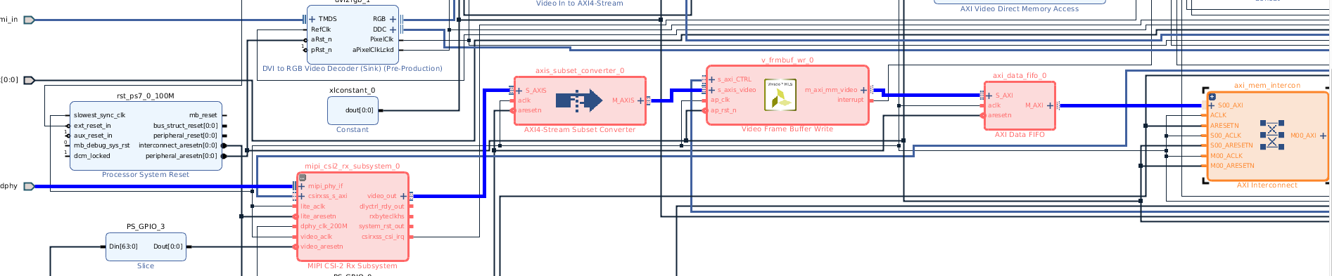
Figure 6 Central IP-core and route of video pipeline

MIPI CSI-2 Rx is a central IP-core of all video pipeline. The MIPI CSI-2 RX subsystem allows you to quickly create systems based on the MIPI protocol. It interfaces between MIPI-based image sensors and an image sensor pipe. All MIPI CSI-2 Rx subsystem architecture is depicated on Figure 7.
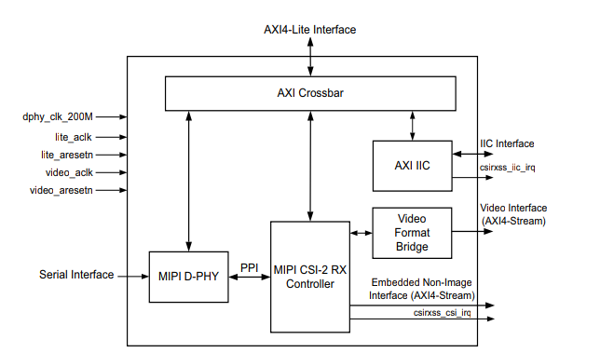

Figure 7 Subsystem architecture

The MIPI D-PHY IP core implements a D-PHY RX interface and provides PHY protocol layer support compatible with the CSI-2 RX interface. The MIPI CSI-2 RX Controller core receives 8-bit data per lane, with support for up to 4 lanes, from the MIPI D-PHY core through the PPI (PHY-Protocol Interface). The byte data received on the PPI is then processed by the low level protocol module to extract the real image information. The final extracted image is made available to the user/processor interface using the AXI4-Stream protocol [6]. Vivado IDE Parameters is shown in Figure 8.

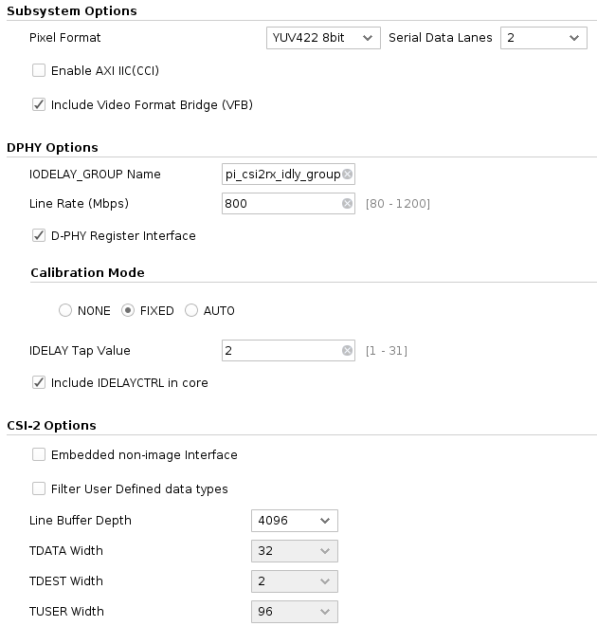

Figure 8 MIPI CSI-2 Rx IP-core options

The next IP-core it is AXI4-Stream Subset Converter. The AXI4-Stream Subset Converter provides a solution for connecting slightly incompatible AXI4-Stream signal sets together. The IP has configurable AXI4-Stream signals for each interface that allows one to convert one signal set to another in consistent manner [7]. Vivado IDE Parameters of this IP-core is shown in Figure 9.

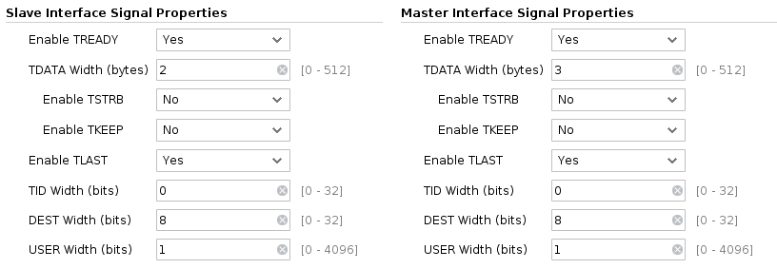

Figure 9 AXI4-Stream Subset Converter options

In the next step, the data stream comes to Video Frame Buffer [8]. The Video Frame Buffer Write IP cores are designed to allow for efficient high-bandwidth access between the AXI4-Stream video interface and the AXI4 interface. The Video Frame Buffer Write is independent IP which support reading and writing a variety of video formats (RGB, YUV 4:4:4, YUV 4:2:2, YUV 4:2:0, and Luma only). The data is packed/unpacked based on the video format. Planar and semi-planar memory formats are available for YUV 4:2:2. This fact is very important to work with Digilent Pcam. Based on this, the parameters for this kernel were set as shown in Figure 10.

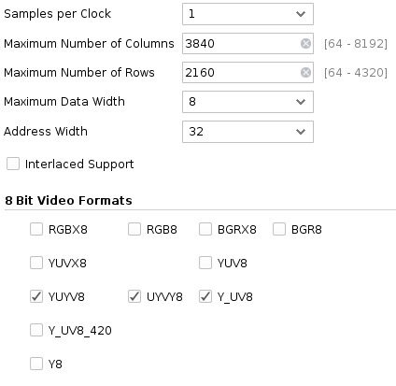

Figure 10 Video Frame Buffer Write options

The AXI Interconnect core connects one or more AXI memory-mapped master devices to
one or more memory-mapped slave devices. Each connected master could be a core that originates AXI transactions (endpoint master) or a master interface of an upstream AXI Interconnect core being cascaded. Also was inserted AXI Data FIFO cores on selected pathways between the SI (Slave Interface), crossbar and MI (Master Interface) within the AXI Interconnect core, to provide data buffering and achieve higher throughput. For each Data FIFO instance, you can selectively enable buffering on the write data channel, read data channel or both. Each connected slave could be the final target of AXI transactions (endpoint slave) or a slave interface of a downstream AXI Interconnect core being cascaded. In our case, the final target of AXI transactions it is Processing System IP-core. From this endpoint, the data stream reaches the DRAM controller and then enters the RAM. The Processing System IP Wrapper acts as a logic connection between the PS and the PL while assisting you to integrate custom and embedded IPs with the processing system. This IP provides configuration and connection of various interfaces to the final project. Custom configuration of Processing System IP-core is shown in Figure 11.

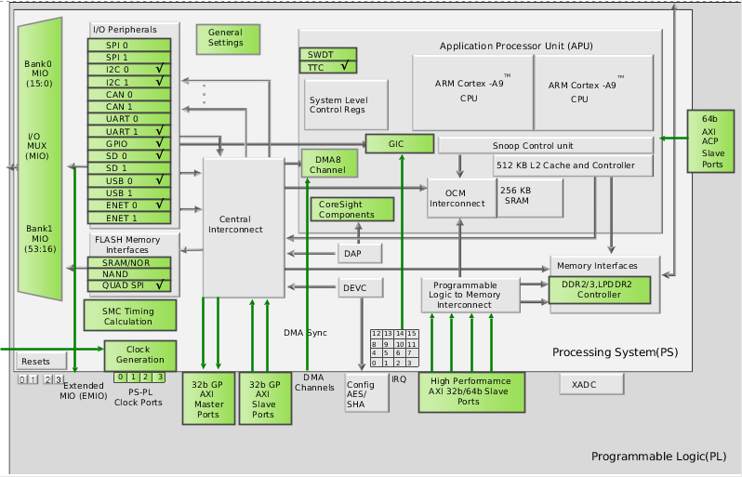

Figure 11 Processing System IP structure and options

Hardware Design Summary

As a result, we received the workable project in Vivado IDE with next final resource utilization (Figure 12) and timing (Figure 13). Also, we received Bitstream file (the configuration file for FPGA) and can use it in the next stages.

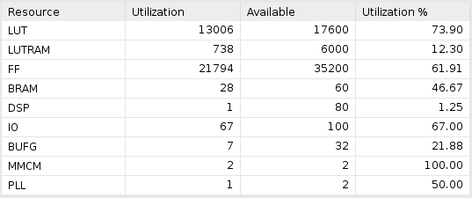

Figure 12 Project Utilization Summary

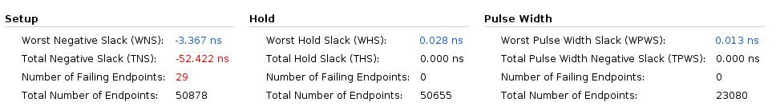
Figure 13 Design Timing Summary

Software Design Description

In this stage we built a custom Embedded Linux distribution based on the Xilinx Petalinux project. Petalinux tools based on Yocto Project, but have meta layers and BSPs provided by Xilinx and Digilent. The distribution is adapted to our needs and includes many packages that will be useful in the future. For example, GCC, V4L2-tools, Yavta and Ffmpeg. Last two packages gave us an opportunity to check the Linux support for the interconnections between camera and the ARM core made through the FPGApart. Also, this software is used to receive some frames from the Pcam camera module.The first frame we acquired(using FFmpeg) is presented on the Figure 14 below.
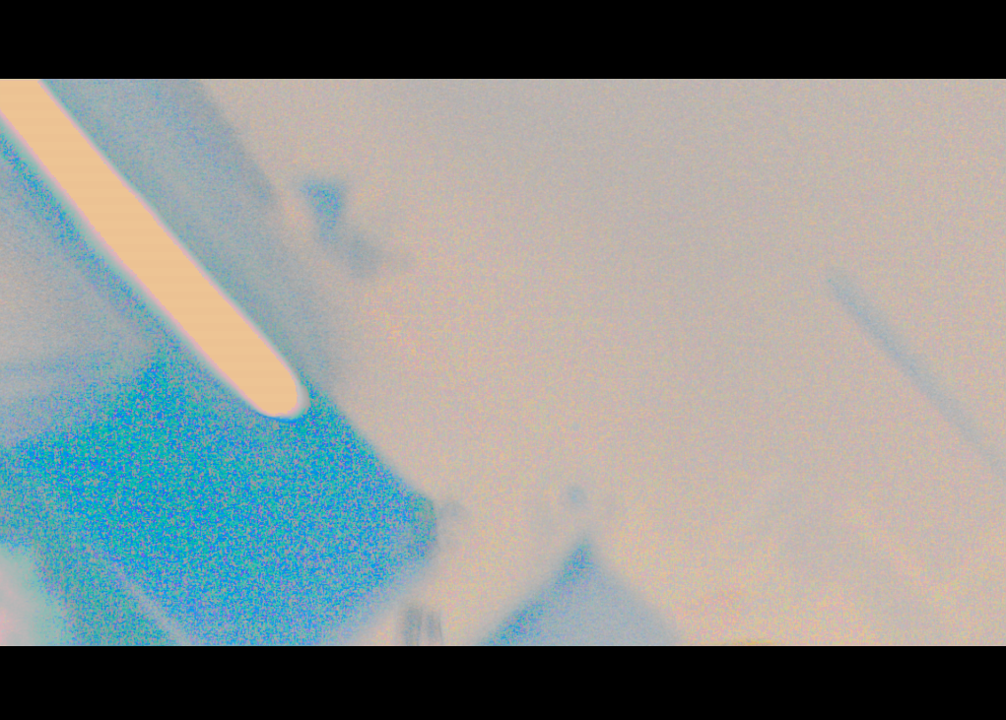

Figure 14 First test frame in RAW format

ARAVIS library was build using Yocto and added to our distribution with a help of the corresponding aravis-meta meta layer. This layer is based on open-source Github project [9]. The layer can also be used for building Aravis for the OpenEmbedded/Angstrom Linux distribution, alongside with the required Gstreamer plugin. A bitbake recipe and patches were added to build the Aravis library. As a result of that stage we have built a Linux distro image, where Aravis stands as a static library (libaravis.so) with all its dependencies.
It has been said that the original distribution of the ARAVIS does not allow direct video streaming from the camera but includes a video viewer and ArvFake camera simulator. The ArvFake imitates the GigE Vision camera, but it can only emit a test video sequence in a form of moving gradient pattern. To avoid that limitation we have largely modified the original source code of the ArvFake component to replace the gradient patterns with actual video flow acquired from the camera. To achieve this goal, we wrote a C program module (code we can see in Appendix A). We used v4l2-tools and realize capture frames from a camera device (in our distribution it is a standard name – video0). As an output, we resulted having a modified ArvFake module, which emits real video stream from camera through the Ethernet link using the GigE Vision-compatible protocols. Ready program module was built with GCC on board and succesfully tested with camera. For visualization we used the ARAVIS-viewer component.

Discussion

Limitations and Problems Encountered

We currently have a working prototype GigE Vision camera, which can transmit stream monochrome FullHD video with 20 FPS via Ethernet link to users. Also, on this stage, our Linux distribution is not real-time. However, this suits us at the prototyping stage. For our project to become true real-time, a series of steps will be done: applying the real-time patches to the Linux kernel; building a custom kernel module to allow for more robust video acquisition (instead of the v4l2 layer); bringing some parts of software from the user space to the kernel space, to comply to even more strict real-time requirements.
During testing of the prototype, we concluded that the use of AXI Video Frame Buffer Write IP-core is not rationalizing. For buffering only for parts of the frame we can use AXI VDMA. Also, Video Frame Buffer Write cores do not use Genlock Synchronization (prevents reading and writing from and to one buffer). We should implement this in software. Video Frame Buffer Write core do not allow for data realignment to the byte (8 bits) level. For example, the addresses must be aligned to multiples of memory mapped data width bytes. The AXI VDMA, therefore, considered as the preferred options for us. However, it is worth checking on the board in the future.

Engineering Resources Used and Marketability

For the full implementation of this project, we need 1600 hours. At this point in the project, we spent 1100 hours. The overall project readiness is about 70%. After we complete the project, we can use this prototype to create your own custom GigE Vision cameras.

Community Feedback

After posting our project in a more early stage we received many project page views (more 1350) on Digilent Project site. We also received a lot of positive feedback from our university department.

References

- T.A. Khodniev et. al., "Comparison of RTSP and GigE Vision Video Streaming Technologies in Terms of Communication Path Utilization Efficiency," Conference materials of 39th IEEE International Conference on ELECTRONICS AND NANOTECHNOLOGY (ELNANO-2019), April 2019
- E. Pacaud, "Aravis – A vision library for genicam based cameras," 2016. [Online]. Available: https://aravisproject.github.io/docs/aravis-0.6/ [Accessed 4, May 2019].
- T.A. Khodniev and A.Y. Varfolomieiev, “Evaluating the efficiency of communication path utilization by RTSP broadcasting protocols in tasks of real-time video sequences transmission,” Conference materials of XIIth International Scientific Conference “Modern challenges in telecommunications”, pp. 332-335, April 2018 [In Russian]
- T.A. Khodniev et. al., "By-Layer Decomposition Model for Evaluating the Integral Communication Path Utilization Efficiency with Account for Errors," MicrosystElectronAcoust, 2018, vol. 23, no. 6 [In Russian]
- Digilent Inc., "Zybo Z7-20 Base Linux Design", 2018. [Online]. Available: https://github.com/Digilent/Zybo-Z7-20-base-linux [Accessed 4, May 2019].
- Xilinx Inc., "MIPI CSI-2 Receiver Subsystem v3.0 [PG232]", 2018. [Online]. Available: https://www.xilinx.com/support/documentation/ip_documentation/v_frmbuf/v1_0/pg278-v-frmbuf.pdf [Accessed 4, May 2019].
- Xilinx Inc., "AXI4-Stream Infrastructure IP Suite v3.0 [PG085]", 2018. [Online]. Available: https://www.xilinx.com/support/documentation/ip_documentation/v_frmbuf/v1_0/pg278-v-frmbuf.pdf [Accessed 4, May 2019].
- Xilinx Inc., "Video Frame Buffer Read/Write v1.0 [PG278]", 2017. [Online]. Available: https://www.xilinx.com/support/documentation/ip_documentation/v_frmbuf/v1_0/pg278-v-frmbuf.pdf [Accessed 4, May 2019].
- Alexander Tarasikov, "meta-aravis – layer for building Aravis for the OpenEmbedded/ Angstrom Linux distribution", 2018. [Online]. Available: https://github.com/astarasikov/meta-aravis [Accessed 4, May 2019].

Appendix A: arvfakegvcamera.c

/* The modified ArvFake component, allowing to stream from
* actual web camera.
* Requires patching the #error block in original source
* otherwise problems arise during build.
* Make sure to see the original LICENSE of ARAVIS
*/
#include "arvbufferprivate.h"
#include <arv.h>
#include <arvgvcp.h>
#include <arvgvsp.h>
#include <ifaddrs.h>
#include <net/if.h>
#include <stdlib.h>
#include <string.h>

#include <assert.h>
#include <math.h>
#include <stdio.h>

#include <getopt.h> /* getopt_long() */

#include <errno.h>
#include <fcntl.h> /* low-level i/o */
#include <sys/ioctl.h>
#include <sys/mman.h>
#include <sys/stat.h>
#include <sys/time.h>
#include <sys/types.h>
#include <unistd.h>

#include <linux/videodev2.h>
#include <stdbool.h>
#include <stdint.h>

#define CLEAR(x) memset(&(x), 0, sizeof(x))
#define LOG(str, ...) fprintf(stderr, str "\n", ##__VA_ARGS__)

struct buffer {
void **start;
size_t *length;
};

unsigned long long width = 0, height = 0, bufsize = 0;

enum captype {
captype_regular = 0, // V4L2_CAP_VIDEO_CAPTURE + V4L2_CAP_STREAMING
captype_mplane // V4L2_CAP_VIDEO_CAPTURE_MPLANE + V4L2_CAP_STREAMING
};

enum { FIX_WIDTH = 1920, FIX_HEIGHT = 1080, FIX_NPLANES = 3 };

static char *dev_name;
static int fd = -1;
struct buffer *buffers;
static unsigned int n_buffers;
enum captype captype;
struct v4l2_format fmt;

// Command-line arguments
static char *arv_option_interface_name = "eth0";
static char *arv_option_camera_devname = "/dev/video0";
static char *arv_option_debug_domains = NULL;
static bool arv_option_is_bw = false;
static bool arv_option_is_force = false;

static const GOptionEntry arv_option_entries[] = {
{ "interface", 'i', 0, G_OPTION_ARG_STRING, &arv_option_interface_name,
"Listening interface name", "interface_id" },
{ "camera", 'c', 0, G_OPTION_ARG_STRING, &arv_option_camera_devname,
"camera device (i.e. /dev/video0)", "camdev" },
{ "bw", 0, 0, G_OPTION_ARG_NONE, &arv_option_is_bw, "black and white mode (Mono8)", NULL },
{ "force", 'f', 0, G_OPTION_ARG_NONE, &arv_option_is_force, "force feature set", NULL },
{ "debug", 'd', 0, G_OPTION_ARG_STRING, &arv_option_debug_domains, NULL,
"category[:level][,...]" },
{ NULL }
};

static void errno_exit(const char *s)
{
fprintf(stderr, "%s error %d, %s\n", s, errno, strerror(errno));
exit(EXIT_FAILURE);
}

static int xioctl(int fh, int request, void *arg)
{
int r;

do {
r = ioctl(fh, request, arg);
} while (-1 == r && EINTR == errno);

return r;
}

int read_frame(void *dst)
{
struct v4l2_buffer buf;
void *frame;

CLEAR(buf);

buf.type = fmt.type;
buf.memory = V4L2_MEMORY_MMAP;
buf.length = fmt.fmt.pix_mp.num_planes;
struct v4l2_plane planes[buf.length];
if (captype == captype_mplane) {
buf.m.planes = planes;
}

if (-1 == xioctl(fd, VIDIOC_DQBUF, &buf)) {
switch (errno) {
case EAGAIN:
return 0;
case EIO:
/* Could ignore EIO, see spec. */
/* fall through */
default:
errno_exit("VIDIOC_DQBUF");
}
}

assert(buf.index < n_buffers);

// process image
if (captype == captype_regular) {
char *p_dst = (char *)dst;
char *p_src = (char *)(buffers[buf.index].start[0]);
while (p_src < (char *)buffers[buf.index].start[0] + buf.bytesused) {
*p_dst = *p_src;
p_dst += 1;
p_src += 2;
}
} else {
memcpy(dst, buffers[0].start[0], bufsize);
}

if (-1 == xioctl(fd, VIDIOC_QBUF, &buf)) {
errno_exit("VIDIOC_QBUF");
}

return 1;
}

void capture(void *dst)
{
for (;;) {
fd_set fds;
struct timeval tv;
int r;

FD_ZERO(&fds);
FD_SET(fd, &fds);
/* Timeout. */
tv.tv_sec = 2;
tv.tv_usec = 0;

r = select(fd + 1, &fds, NULL, NULL, &tv);

if (-1 == r) {
if (EINTR == errno)
continue;
errno_exit("select");
}
if (0 == r) {
fprintf(stderr, "select timeout\n");
exit(EXIT_FAILURE);
}

if (read_frame(dst))
break;
}
}

static void start_capturing(void)
{
unsigned int i;
enum v4l2_buf_type type;
struct v4l2_buffer buf;

if (captype == captype_regular) {
for (i = 0; i < n_buffers && captype == captype_regular; ++i) {
CLEAR(buf);
buf.type = fmt.type;
buf.memory = V4L2_MEMORY_MMAP;
buf.index = i;
}

if (-1 == xioctl(fd, VIDIOC_QBUF, &buf))
errno_exit("VIDIOC_QBUF");
} else {
CLEAR(buf);
buf.type = fmt.type;
buf.memory = V4L2_MEMORY_MMAP;
buf.index = 0;

buf.length = fmt.fmt.pix_mp.num_planes;
struct v4l2_plane planes[buf.length];
buf.m.planes = planes;

if (-1 == xioctl(fd, VIDIOC_QBUF, &buf))
errno_exit("VIDIOC_QBUF");
}

type = fmt.type;
if (-1 == xioctl(fd, VIDIOC_STREAMON, &type))
errno_exit("VIDIOC_STREAMON");
}

static void stop_capturing(void)
{
enum v4l2_buf_type type;

type = fmt.type;
if (-1 == xioctl(fd, VIDIOC_STREAMOFF, &type))
errno_exit("VIDIOC_STREAMOFF");
}

static void uninit_device(void)
{
unsigned int i;

for (i = 0; i < n_buffers; ++i) {
if (captype == captype_mplane) {
for (int j = 0; j < n_buffers; j++) {
if (-1 == munmap(buffers[i].start[j], buffers[i].length[j]))
errno_exit("munmap (mplane)");
}
} else if (-1 == munmap(buffers[i].start[0], buffers[i].length[0])) {
errno_exit("munmap (non-plane)");
}
free(buffers[i].start);
free(buffers[i].length);
}

free(buffers);
}

static void init_device(void)
{
// Xilinx supported flags:
// V4L2_CAP_VIDEO_CAPTURE_MPLANE
// V4L2_CAP_EXT_PIX_FORMAT
// V4L2_CAP_STREAMING
// V4L2_CAP_DEVICE_CAPS

struct v4l2_capability cap;
struct v4l2_cropcap cropcap;
struct v4l2_crop crop;
unsigned int min;

if (-1 == xioctl(fd, VIDIOC_QUERYCAP, &cap)) {
if (EINVAL == errno) {
fprintf(stderr, "%s is not a V4L2 device\n", dev_name);
exit(EXIT_FAILURE);
} else {
errno_exit("VIDIOC_QUERYCAP");
}
}

if (!(cap.capabilities & V4L2_CAP_STREAMING)) {
fprintf(stderr, "%s does not support streaming i/o\n", dev_name);
exit(EXIT_FAILURE);
}

if (cap.capabilities & V4L2_CAP_VIDEO_CAPTURE_MPLANE) {
captype = captype_mplane;
LOG("Capture format set to *mplane* (flags: 0x%llx)", cap.capabilities);
} else if (cap.capabilities & V4L2_CAP_VIDEO_CAPTURE) {
captype = captype_regular;
LOG("Capture format set to *regular* (flags: 0x%llx)", cap.capabilities);
} else {
fprintf(stderr, "%s does not support neither regular nor mplane capture\n", dev_name);
exit(EXIT_FAILURE);
}

CLEAR(fmt);

if (captype_regular == captype) {
fmt.type = V4L2_BUF_TYPE_VIDEO_CAPTURE;
} else if (captype_mplane == captype) {
fmt.type = V4L2_BUF_TYPE_VIDEO_CAPTURE_MPLANE;
} else {
LOG("Unknown capture type");
}

// partially fill the struct with reported capabilities
if (-1 == xioctl(fd, VIDIOC_G_FMT, &fmt))
errno_exit("VIDIOC_G_FMT");

// apply fixtures in case of broken driver
if (arv_option_is_force) {
LOG("Applying forceful fixtures");
fmt.fmt.pix_mp.width = FIX_WIDTH;
fmt.fmt.pix_mp.height = FIX_HEIGHT;
fmt.fmt.pix_mp.num_planes = FIX_NPLANES;
fmt.fmt.pix_mp.pixelformat = V4L2_PIX_FMT_YUYV;
fmt.fmt.pix_mp.field = V4L2_FIELD_NONE;
}

unsigned int _np1 = fmt.fmt.pix_mp.num_planes;
printf("NUM PLANES: %u\n", _np1);
LOG("Got from driver:\n\t"
"type: 0x%lx (%s)\n\t"
"resolution: %dx%d\n\t"
"pixfmt: 0x%llx\n\t"
"field: 0x%llx\n\t"
"nplanes: %u\n",
(long)(fmt.type), (captype == captype_regular ? "regular" : "mplane"),
(int)(captype == captype_regular ? fmt.fmt.pix.width : +fmt.fmt.pix_mp.width),
(int)(captype == captype_regular ? fmt.fmt.pix.height : fmt.fmt.pix_mp.height),
(long int)(captype == captype_regular ? fmt.fmt.pix.pixelformat :
fmt.fmt.pix_mp.pixelformat),
(long int)(captype == captype_regular ? fmt.fmt.pix.field : fmt.fmt.pix_mp.field),
(captype == captype_mplane ? _np1 : 0U));

// set pixel format
if (-1 == xioctl(fd, VIDIOC_S_FMT, &fmt))
errno_exit("VIDIOC_S_FMT");
/* Note VIDIOC_S_FMT may change width and height. */

// init mmap
struct v4l2_requestbuffers req;
CLEAR(req);

req.type = fmt.type;
req.memory = V4L2_MEMORY_MMAP;
// request exact nplanes if mplane type, on normal use 4
int count = (captype_mplane == captype) ? fmt.fmt.pix_mp.num_planes : 3;
req.count = count;

if (-1 == xioctl(fd, VIDIOC_REQBUFS, &req)) {
if (EINVAL == errno) {
fprintf(stderr,
"Failed to request buffers. Probably %s does not support memory mapping\n",
dev_name);
exit(EXIT_FAILURE);
} else {
errno_exit("VIDIOC_REQBUFS");
}
}

if (req.count < count) {
fprintf(stderr, "Insufficient buffer memory on %s\n", dev_name);
exit(EXIT_FAILURE);
}

if (!(buffers = calloc(count, sizeof(*buffers))))
goto buf_alloc_err;

for (int i = 0; i < req.count; i++) {
if (!(buffers[i].start = calloc(count, sizeof(*buffers[i].start))))
goto buf_alloc_err;
if (!(buffers[i].length = calloc(count, sizeof(*buffers[i].length))))
goto buf_alloc_err;
}

// query buffers
for (n_buffers = 0; n_buffers < count; ++n_buffers) {
struct v4l2_buffer buf;
struct v4l2_plane planes[count];

CLEAR(buf);
CLEAR(planes);

buf.type = fmt.type;
buf.memory = V4L2_MEMORY_MMAP;
buf.index = n_buffers;

if (captype_mplane == captype) {
buf.m.planes = planes;
buf.length = req.count;
}

if (-1 == xioctl(fd, VIDIOC_QUERYBUF, &buf)) {
errno_exit("VIDIOC_QUERYBUF");
}

if (captype_mplane != captype) {
buffers[n_buffers].length[0] = buf.length;
buffers[n_buffers].start[0] = mmap(NULL, /* start anywhere */
buf.length, PROT_READ | PROT_WRITE, /* required */
MAP_SHARED, /* recommended */
fd, buf.m.offset);

if (MAP_FAILED == buffers[n_buffers].start[0])
errno_exit("mmap buffers (non-plane)");

LOG("REGULAR Buffer #%d: len = %d, start = 0x%llx mmaped", (int)n_buffers,
(int)buffers[n_buffers].length[0], (long long)buffers[n_buffers].start[0]);

continue;
}

// in case of nplanes
for (int i = 0; i < 1; i++) {
buffers[n_buffers].length[i] = buf.m.planes[i].length;
buffers[n_buffers].start[i] = mmap(NULL, buf.m.planes[i].length,
PROT_READ | PROT_WRITE, MAP_SHARED, fd,
buf.m.planes[i].m.mem_offset);
if (MAP_FAILED == buffers[n_buffers].start[i]) {
errno_exit("mmap buffers (plane)");
}

LOG("MPLANE Buffer #%d.%d: len = %ld, start = 0x%llx mmaped", (int)n_buffers, (int)i,
(long)buffers[n_buffers].length[i], (long long)buffers[n_buffers].start[i]);
}
}

LOG("MMAP OK...");

return;

// err handlers
buf_alloc_err:
fprintf(stderr, "Out of memory\n");
exit(EXIT_FAILURE);
}

static void open_device(void)
{
struct stat st;

if (-1 == stat(dev_name, &st)) {
fprintf(stderr, "Cannot identify '%s': %d, %s\n", dev_name, errno, strerror(errno));
exit(EXIT_FAILURE);
}

if (!S_ISCHR(st.st_mode)) {
fprintf(stderr, "%s is no device\n", dev_name);
exit(EXIT_FAILURE);
}

fd = open(dev_name, O_RDWR /* required */ | O_NONBLOCK, 0);

if (-1 == fd) {
fprintf(stderr, "Cannot open '%s': %d, %s\n", dev_name, errno, strerror(errno));
exit(EXIT_FAILURE);
}
}

static void close_device(void)
{
if (-1 == close(fd))
errno_exit("close");

fd = -1;
}

#define ARV_FAKE_GV_CAMERA_BUFFER_SIZE 655360

static gboolean cancel = FALSE;

static void set_cancel(int signal)
{
cancel = TRUE;
}

typedef struct {
ArvFakeCamera *camera;
GPollFD gvcp_fds[2];
guint n_gvcp_fds;

GSocketAddress *controller_address;
struct timespec controller_time;

GSocket *gvcp_socket;
GSocket *gvsp_socket;
GSocket *discovery_socket;

GThread *gvsp_thread;
gboolean cancel;
} ArvFakeGvCamera;

gboolean _g_inet_socket_address_is_equal(GInetSocketAddress *a, GInetSocketAddress *b)
{
GInetAddress *a_addr;
GInetAddress *b_addr;
char *a_str;
char *b_str;
gboolean result;

if (!G_IS_INET_SOCKET_ADDRESS(a) || !G_IS_INET_SOCKET_ADDRESS(b))
return FALSE;

if (g_inet_socket_address_get_port(a) != g_inet_socket_address_get_port(b))
return FALSE;

a_addr = g_inet_socket_address_get_address(a);
b_addr = g_inet_socket_address_get_address(b);

a_str = g_inet_address_to_string(a_addr);
b_str = g_inet_address_to_string(b_addr);

/* TODO: find a better way to do inet address comparison */
result = g_strcmp0(a_str, b_str) == 0;

g_free(a_str);
g_free(b_str);

return result;
}

void *arv_fake_gv_camera_thread(void *user_data)
{
ArvFakeGvCamera *gv_camera = user_data;
ArvBuffer *image_buffer = NULL;
GError *error = NULL;
GSocketAddress *stream_address = NULL;
void *packet_buffer;
size_t packet_size;
size_t payload = 0;
guint16 block_id;
ptrdiff_t offset;
guint32 gv_packet_size;

packet_buffer = g_malloc(bufsize);

do {
if (arv_fake_camera_get_control_channel_privilege(gv_camera->camera) == 0
|| arv_fake_camera_get_acquisition_status(gv_camera->camera) == 0) {
if (stream_address != NULL) {
g_object_unref(stream_address);
stream_address = NULL;
g_object_unref(image_buffer);
image_buffer = NULL;
arv_debug_stream_thread("[FakeGvCamera::stream_thread] Stop stream");
}
g_usleep(100000);
} else {
if (stream_address == NULL) {
GInetAddress *inet_address;
char *inet_address_string;

stream_address = arv_fake_camera_get_stream_address(gv_camera->camera);
inet_address =
g_inet_socket_address_get_address(G_INET_SOCKET_ADDRESS(stream_address));
inet_address_string = g_inet_address_to_string(inet_address);
arv_debug_stream_thread(
"[FakeGvCamera::stream_thread] Start stream to %s (%d)",
inet_address_string,
g_inet_socket_address_get_port(G_INET_SOCKET_ADDRESS(stream_address)));
g_free(inet_address_string);

payload = arv_fake_camera_get_payload(gv_camera->camera);
image_buffer = arv_buffer_new(payload, NULL);
}

arv_fake_camera_wait_for_next_frame(gv_camera->camera);
arv_fake_camera_fill_buffer(gv_camera->camera, image_buffer, &gv_packet_size);

block_id = 0;

packet_size = bufsize;
arv_gvsp_packet_new_data_leader(
image_buffer->priv->frame_id, block_id, image_buffer->priv->timestamp_ns,
image_buffer->priv->pixel_format, image_buffer->priv->width,
image_buffer->priv->height, image_buffer->priv->x_offset,
image_buffer->priv->y_offset, packet_buffer, &packet_size);

g_socket_send_to(gv_camera->gvsp_socket, stream_address, packet_buffer, packet_size,
NULL, &error);
if (error != NULL) {
arv_warning_stream_thread(
"[ArvFakeGvCamera::stream_thread] Socket send error [%s]", error->message);
g_error_free(error);
error = NULL;
}

block_id++;

offset = 0;
while (offset < payload) {
size_t data_size;

data_size =
MIN(gv_packet_size - ARV_GVSP_PACKET_PROTOCOL_OVERHEAD, payload - offset);

packet_size = bufsize;
arv_gvsp_packet_new_data_block(image_buffer->priv->frame_id, block_id, data_size,
((char *)image_buffer->priv->data) + offset,
packet_buffer, &packet_size);

g_socket_send_to(gv_camera->gvsp_socket, stream_address, packet_buffer,
packet_size, NULL, NULL);

offset += data_size;
block_id++;
}

packet_size = bufsize;
arv_gvsp_packet_new_data_trailer(image_buffer->priv->frame_id, block_id, packet_buffer,
&packet_size);

g_socket_send_to(gv_camera->gvsp_socket, stream_address, packet_buffer, packet_size,
NULL, NULL);
}
} while (!cancel);

if (stream_address != NULL)
g_object_unref(stream_address);
if (image_buffer != NULL)
g_object_unref(image_buffer);

g_free(packet_buffer);

return NULL;
}

ArvFakeGvCamera *arv_fake_gv_camera_new(const char *interface_name, const char *filename)
{
ArvFakeGvCamera *gv_camera;
struct ifaddrs *ifap = NULL;
struct ifaddrs *ifap_iter;
int return_value;
gboolean interface_found = FALSE;
gboolean binding_error = FALSE;

g_return_val_if_fail(interface_name != NULL, NULL);
if (filename) {
arv_set_fake_camera_genicam_filename(filename);
}

gv_camera = g_new0(ArvFakeGvCamera, 1);
gv_camera->camera = arv_fake_camera_new("GV01");

return_value = getifaddrs(&ifap);
if (return_value < 0) {
g_warning("[FakeGvCamera::new] No network interface found");
return NULL;
}

for (ifap_iter = ifap; ifap_iter != NULL && !interface_found;
ifap_iter = ifap_iter->ifa_next) {
if ((ifap_iter->ifa_flags & IFF_UP) != 0 && (ifap_iter->ifa_flags & IFF_POINTOPOINT) == 0
&& (ifap_iter->ifa_addr->sa_family == AF_INET)
&& g_strcmp0(ifap_iter->ifa_name, interface_name) == 0) {
GSocketAddress *socket_address;
GSocketAddress *inet_socket_address;
GInetAddress *inet_address;
char *gvcp_address_string;
char *discovery_address_string;

socket_address =
g_socket_address_new_from_native(ifap_iter->ifa_addr, sizeof(struct sockaddr));
inet_address =
g_inet_socket_address_get_address(G_INET_SOCKET_ADDRESS(socket_address));
gvcp_address_string = g_inet_address_to_string(inet_address);
arv_debug_device("[FakeGvCamera::new] Interface address = %s", gvcp_address_string);

inet_socket_address = g_inet_socket_address_new(inet_address, ARV_GVCP_PORT);
gv_camera->gvcp_socket = g_socket_new(G_SOCKET_FAMILY_IPV4, G_SOCKET_TYPE_DATAGRAM,
G_SOCKET_PROTOCOL_UDP, NULL);
if (!g_socket_bind(gv_camera->gvcp_socket, inet_socket_address, FALSE, NULL))
binding_error = TRUE;
g_socket_set_blocking(gv_camera->gvcp_socket, FALSE);
arv_fake_camera_set_inet_address(gv_camera->camera, inet_address);
g_object_unref(inet_socket_address);

inet_socket_address = g_inet_socket_address_new(inet_address, 0);
gv_camera->gvsp_socket = g_socket_new(G_SOCKET_FAMILY_IPV4, G_SOCKET_TYPE_DATAGRAM,
G_SOCKET_PROTOCOL_UDP, NULL);
if (!g_socket_bind(gv_camera->gvsp_socket, inet_socket_address, FALSE, NULL))
binding_error = TRUE;
g_object_unref(inet_socket_address);

g_object_unref(socket_address);

inet_address = g_inet_address_new_from_string("255.255.255.255");
discovery_address_string = g_inet_address_to_string(inet_address);
arv_debug_device("[FakeGvCamera::new] Discovery address = %s",
discovery_address_string);
inet_socket_address = g_inet_socket_address_new(inet_address, ARV_GVCP_PORT);
if (g_strcmp0(gvcp_address_string, discovery_address_string) == 0)
gv_camera->discovery_socket = NULL;
else {
gv_camera->discovery_socket = g_socket_new(
G_SOCKET_FAMILY_IPV4, G_SOCKET_TYPE_DATAGRAM, G_SOCKET_PROTOCOL_UDP, NULL);
if (!g_socket_bind(gv_camera->discovery_socket, inet_socket_address, FALSE, NULL))
binding_error = TRUE;
g_socket_set_blocking(gv_camera->discovery_socket, FALSE);
}
g_object_unref(inet_socket_address);

g_free(gvcp_address_string);
g_free(discovery_address_string);

gv_camera->gvcp_fds[0].fd = g_socket_get_fd(gv_camera->gvcp_socket);
gv_camera->gvcp_fds[0].events = G_IO_IN;
gv_camera->gvcp_fds[0].revents = 0;
if (gv_camera->discovery_socket != NULL) {
gv_camera->gvcp_fds[1].fd = g_socket_get_fd(gv_camera->discovery_socket);
gv_camera->gvcp_fds[1].events = G_IO_IN;
gv_camera->gvcp_fds[1].revents = 0;
gv_camera->n_gvcp_fds = 2;
} else
gv_camera->n_gvcp_fds = 1;

interface_found = TRUE;
}
}

freeifaddrs(ifap);

if (binding_error)
goto BINDING_ERROR;

if (!interface_found)
goto INTERFACE_ERROR;

gv_camera->cancel = FALSE;
gv_camera->gvsp_thread =
g_thread_new("arv_fake_gv_camera", arv_fake_gv_camera_thread, gv_camera);

return gv_camera;

BINDING_ERROR:
fprintf(stderr, "Interface binding error\n");
g_object_unref(gv_camera->gvcp_socket);
if (gv_camera->discovery_socket != NULL)
g_object_unref(gv_camera->discovery_socket);
g_object_unref(gv_camera->gvsp_socket);

INTERFACE_ERROR:
fprintf(stderr, "Interface error\n");
g_object_unref(gv_camera->camera);
g_free(gv_camera);

return NULL;
}

void arv_fake_gv_camera_free(ArvFakeGvCamera *gv_camera)
{
g_return_if_fail(gv_camera != NULL);

if (gv_camera->gvsp_thread != NULL) {
gv_camera->cancel = TRUE;
g_thread_join(gv_camera->gvsp_thread);
gv_camera->gvsp_thread = NULL;
}

g_object_unref(gv_camera->gvcp_socket);
if (gv_camera->discovery_socket != NULL)
g_object_unref(gv_camera->discovery_socket);
g_object_unref(gv_camera->camera);
if (gv_camera->controller_address != NULL)
g_object_unref(gv_camera->controller_address);
g_free(gv_camera);
}

void handle_control_packet(ArvFakeGvCamera *gv_camera, GSocket *socket,
GSocketAddress *remote_address, ArvGvcpPacket *packet, size_t size)
{
ArvGvcpPacket *ack_packet = NULL;
size_t ack_packet_size;
guint32 block_address;
guint32 block_size;
guint16 packet_id;
guint32 register_address;
guint32 register_value;
gboolean write_access;

if (gv_camera->controller_address != NULL) {
struct timespec time;
guint64 elapsed_ms;

clock_gettime(CLOCK_MONOTONIC, &time);

elapsed_ms = 1000 * (time.tv_sec - gv_camera->controller_time.tv_sec)
+ (time.tv_nsec - gv_camera->controller_time.tv_nsec) / 1000000;

if (elapsed_ms > arv_fake_camera_get_heartbeat_timeout(gv_camera->camera)) {
g_object_ref(gv_camera->controller_address);
gv_camera->controller_address = NULL;
write_access = TRUE;
arv_warning_device("[FakeGvCamera::handle_control_packet] Heartbeat timeout");
arv_fake_camera_set_control_channel_privilege(gv_camera->camera, 0);
} else
write_access = _g_inet_socket_address_is_equal(
G_INET_SOCKET_ADDRESS(remote_address),
G_INET_SOCKET_ADDRESS(gv_camera->controller_address));
} else
write_access = TRUE;

arv_gvcp_packet_debug(packet, ARV_DEBUG_LEVEL_LOG);

packet_id = arv_gvcp_packet_get_packet_id(packet);

switch (g_ntohs(packet->header.command)) {
case ARV_GVCP_COMMAND_DISCOVERY_CMD:
ack_packet = arv_gvcp_packet_new_discovery_ack(&ack_packet_size);
arv_debug_device("[FakeGvCamera::handle_control_packet] Discovery command");
arv_fake_camera_read_memory(gv_camera->camera, 0, ARV_GVBS_DISCOVERY_DATA_SIZE,
&ack_packet->data);
break;
case ARV_GVCP_COMMAND_READ_MEMORY_CMD:
arv_gvcp_packet_get_read_memory_cmd_infos(packet, &block_address, &block_size);
arv_debug_device("[FakeGvCamera::handle_control_packet] Read memory command %d (%d)",
block_address, block_size);
ack_packet = arv_gvcp_packet_new_read_memory_ack(block_address, block_size, packet_id,
&ack_packet_size);
arv_fake_camera_read_memory(gv_camera->camera, block_address, block_size,
arv_gvcp_packet_get_read_memory_ack_data(ack_packet));
break;
case ARV_GVCP_COMMAND_WRITE_MEMORY_CMD:
if (!write_access)
break;

arv_gvcp_packet_get_write_memory_cmd_infos(packet, &block_address, &block_size);
arv_debug_device("[FakeGvCamera::handle_control_packet] Write memory command %d (%d)",
block_address, block_size);
arv_fake_camera_write_memory(gv_camera->camera, block_address, block_size,
arv_gvcp_packet_get_write_memory_cmd_data(packet));
ack_packet =
arv_gvcp_packet_new_write_memory_ack(block_address, packet_id, &ack_packet_size);
break;
case ARV_GVCP_COMMAND_READ_REGISTER_CMD:
arv_gvcp_packet_get_read_register_cmd_infos(packet, &register_address);
arv_fake_camera_read_register(gv_camera->camera, register_address, &register_value);
arv_debug_device("[FakeGvCamera::handle_control_packet] Read register command %d -> %d",
register_address, register_value);
ack_packet =
arv_gvcp_packet_new_read_register_ack(register_value, packet_id, &ack_packet_size);

if (register_address == ARV_GVBS_CONTROL_CHANNEL_PRIVILEGE_OFFSET)
clock_gettime(CLOCK_MONOTONIC, &gv_camera->controller_time);

break;
case ARV_GVCP_COMMAND_WRITE_REGISTER_CMD:
if (!write_access)
break;

arv_gvcp_packet_get_write_register_cmd_infos(packet, &register_address, &register_value);
arv_fake_camera_write_register(gv_camera->camera, register_address, register_value);
arv_debug_device("[FakeGvCamera::handle_control_packet] Write register command %d -> %d",
register_address, register_value);
ack_packet = arv_gvcp_packet_new_write_register_ack(register_value, packet_id,
&ack_packet_size);
break;
default:
arv_warning_device("[FakeGvCamera::handle_control_packet] Unknown command");
}

if (ack_packet != NULL) {
g_socket_send_to(socket, remote_address, (char *)ack_packet, ack_packet_size, NULL, NULL);
arv_gvcp_packet_debug(ack_packet, ARV_DEBUG_LEVEL_LOG);
g_free(ack_packet);
}

if (gv_camera->controller_address == NULL
&& arv_fake_camera_get_control_channel_privilege(gv_camera->camera) != 0) {
g_object_ref(remote_address);
gv_camera->controller_address = remote_address;
clock_gettime(CLOCK_MONOTONIC, &gv_camera->controller_time);
}
}

unsigned char *img = NULL;

void fill_pattern_callback(ArvBuffer *buffer, void *fill_pattern_data, guint32 exposure_time_us,
guint32 gain, ArvPixelFormat pixel_format)
{
double pixel_value;
double scale;
guint32 x, y;
guint32 width;
guint32 height;
int size;

if (buffer == NULL)
return;

if (pixel_format != ARV_PIXEL_FORMAT_MONO_8)
return;

width = buffer->priv->width;
height = buffer->priv->height;

size = width * height * sizeof(unsigned char);
if (!img) {
img = (unsigned char *)malloc(2 * size);

scale = 1.0 + gain + log10((double)exposure_time_us / 10000.0);

for (y = 0; y < height; y++) {
for (x = 0; x < width; x++) {
pixel_value = (x + y) % 255;
pixel_value *= scale;

if (pixel_value < 0.0)
img[y * width + x] = 0;
else if (pixel_value > 255.0)
img[y * width + x] = 255;
else
img[y * width + x] = pixel_value;
}
}

memcpy(img + size, img, size);
memcpy(buffer->priv->data, img, size);
} else {
int offset = (buffer->priv->frame_id % height) * width * sizeof(unsigned char);
memcpy(buffer->priv->data, img + offset, size);
}
}

void fill_v4l_callback(ArvBuffer *buffer, void *fill_pattern_data, guint32 exposure_time_us,
guint32 gain, ArvPixelFormat pixel_format)
{
double pixel_value;
double scale;
guint32 width;
guint32 height;

if (buffer == NULL)
return;

width = buffer->priv->width;
height = buffer->priv->height;

capture(buffer->priv->data);
}

int main(int argc, char **argv)
{
ArvFakeGvCamera *gv_camera;
int n_events;
GInputVector input_vector;
GOptionContext *context;
GError *error = NULL;
int init_status;

g_thread_init(NULL);
g_type_init();

context = g_option_context_new(NULL);
g_option_context_set_summary(context, "Fake GigEVision camera.");
g_option_context_set_description(context, "Example: 'fake-cam -i eth0 -c /dev/video0'");
g_option_context_add_main_entries(context, arv_option_entries, NULL);

if (!g_option_context_parse(context, &argc, &argv, &error)) {
g_option_context_free(context);
g_print("Option parsing failed: %s\n", error->message);
g_error_free(error);
return EXIT_FAILURE;
}

g_option_context_free(context);

// working here
dev_name = arv_option_camera_devname;
open_device();
init_device();
width = captype == captype_mplane ? (unsigned long long)fmt.fmt.pix_mp.width :
(unsigned long long)fmt.fmt.pix.width;
height = captype == captype_mplane ? (unsigned long long)fmt.fmt.pix_mp.height :
(unsigned long long)fmt.fmt.pix.height;
bufsize = width * height;
LOG("Setting buffer size to %llu x %llu (%llu bytes)", width, height, bufsize);
input_vector.buffer = g_malloc0(bufsize);
input_vector.size = bufsize;

printf("Pixel format: %s\n", arv_option_is_bw ? "Mono8 bw" : "YUYV 4:2:2");

arv_debug_enable(arv_option_debug_domains);

if (g_file_test("arv-fake-camera.xml", G_FILE_TEST_EXISTS)) {
gv_camera = arv_fake_gv_camera_new(arv_option_interface_name, "arv-fake-camera.xml");
} else {
gv_camera = arv_fake_gv_camera_new(arv_option_interface_name, NULL);
}
if (gv_camera == NULL) {
g_print("Can't instantiate a new fake camera.\n");
g_print("An existing instance may already use the '%s' interface.\n",
arv_option_interface_name);
return EXIT_FAILURE;
}

start_capturing();

//arv_fake_camera_set_fill_pattern (gv_camera->camera, fill_pattern_callback, NULL);
arv_fake_camera_set_fill_pattern(gv_camera->camera, fill_v4l_callback, NULL);

signal(SIGINT, set_cancel);

do {
n_events = g_poll(gv_camera->gvcp_fds, 2, 1000);
if (arv_option_debug_domains != NULL) {
g_print("n_events = %d\n", n_events);
}
if (n_events > 0) {
GSocketAddress *remote_address;
int count;

int flags = G_SOCKET_MSG_NONE;
count = g_socket_receive_message(gv_camera->gvcp_socket, &remote_address,
&input_vector, 1, NULL, NULL, &flags, NULL, NULL);
if (count > 0)
handle_control_packet(gv_camera, gv_camera->gvcp_socket, remote_address,
input_vector.buffer, count);

if (gv_camera->discovery_socket != NULL) {
int flags = G_SOCKET_MSG_NONE;
count = g_socket_receive_message(gv_camera->discovery_socket, &remote_address,
&input_vector, 1, NULL, NULL, &flags, NULL, NULL);
if (count > 0)
handle_control_packet(gv_camera, gv_camera->discovery_socket, remote_address,
input_vector.buffer, count);
}
}
} while (!cancel);

stop_capturing();
uninit_device();
close_device();

g_free(input_vector.buffer);

arv_fake_gv_camera_free(gv_camera);

return EXIT_SUCCESS;
}

